**Project3-E-commerce-website-for-Sporty-Shoes**

**How to run the program**

• clone project to your springtool

• Go application.properties and change the database name and your mysql password.

• Now right click on project run program Spring boot

• Once the server is started you can open your browser and type localhost:8087 and press Enter

* You can view the login screen here.

You can login as admin with below credential:

Username: admin Password: admin

Same goes with User:

Username: user Password: user

Once you are logged in with admin then you can add edit and delete the product from the database and logout

When your logged in with user, You can view all the product details, can add product to cart, can buy the product and can view the order summary.

**Screenshots:**

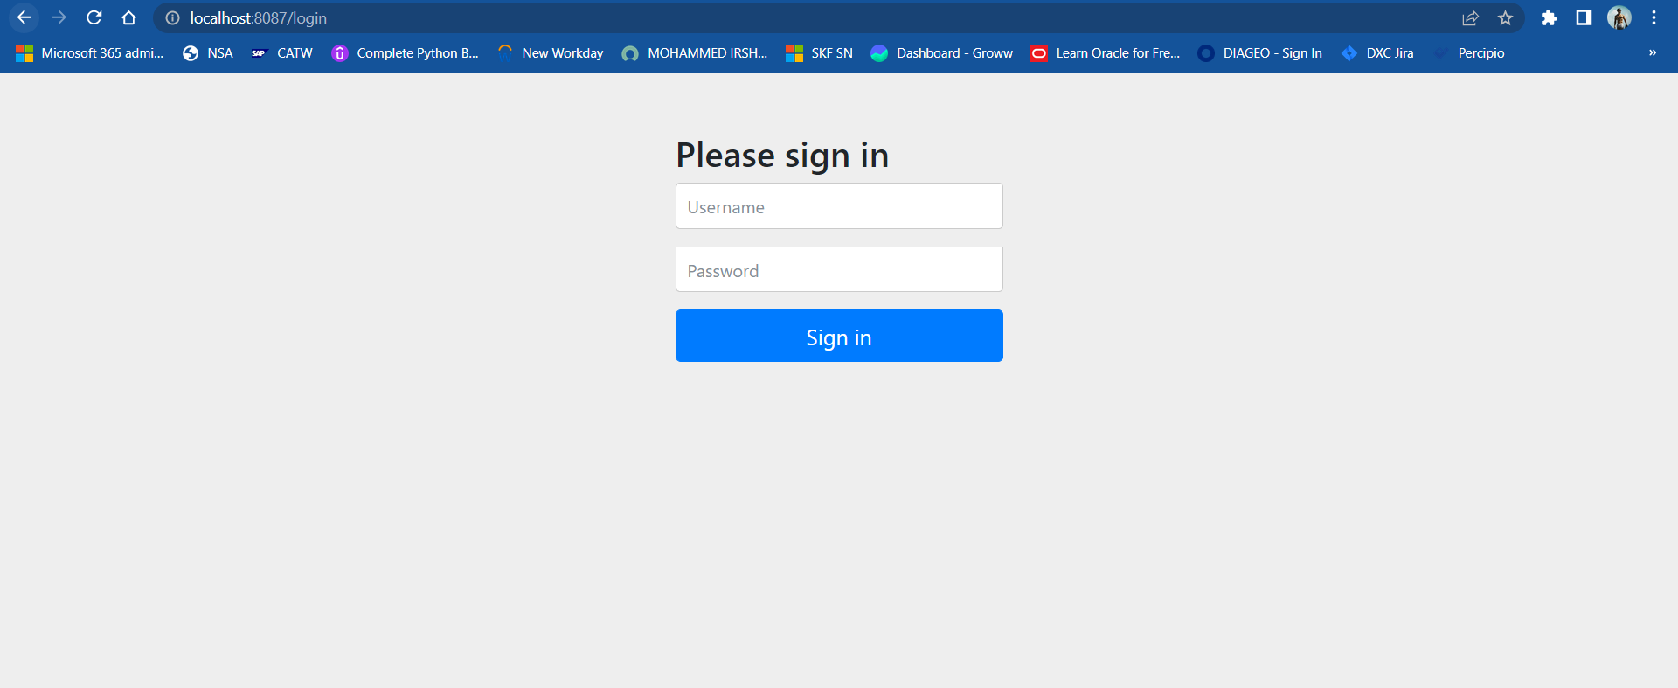

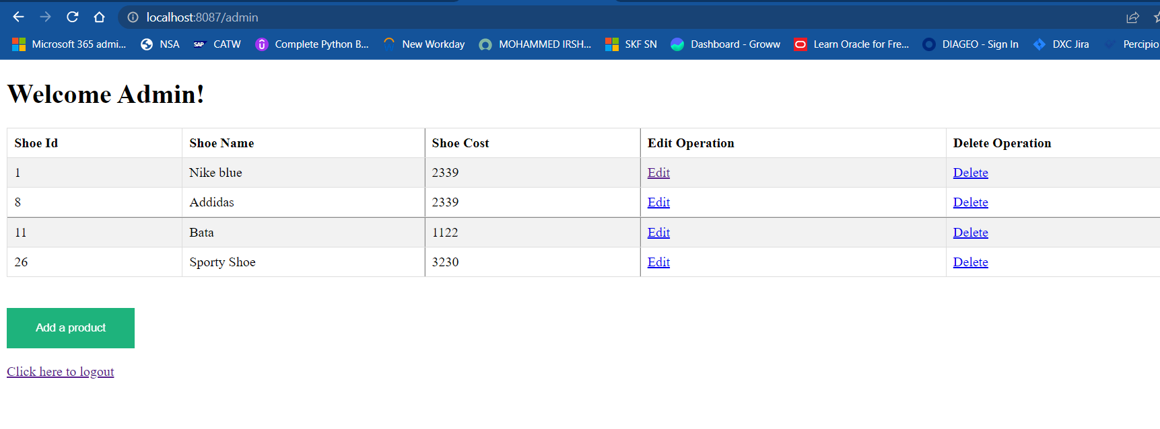

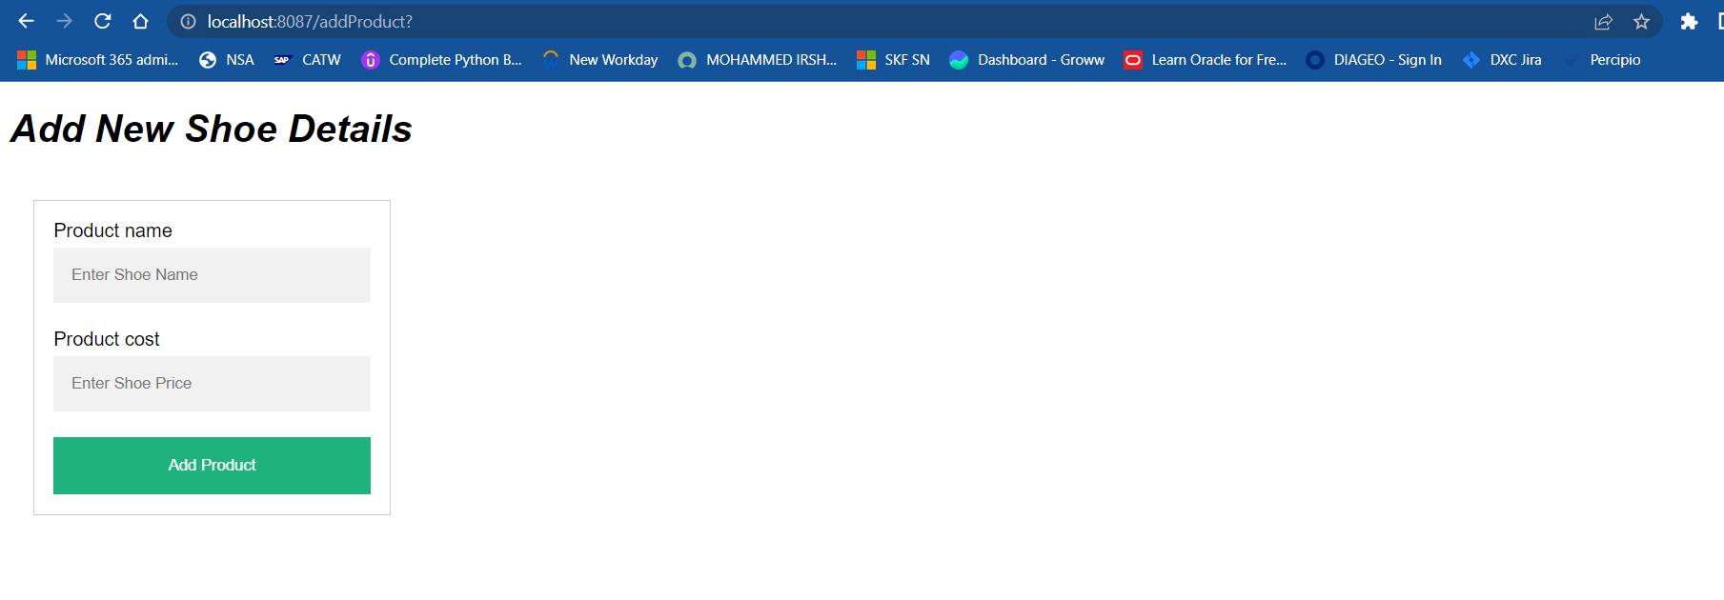

User Login:

